Model Optimization and Tuning Phase Template

Date | 15 November 2024
Team ID | 739824
Project Title | Fertilizer Recommendation System For Agriculture Using Ai
Maximum Marks | 10 Marks

Model Optimization and Tuning Phase
The Model Optimization and Tuning Phase involves refining neural network models for peak performance. It includes optimized model code, fine-tuning hyperparameters, comparing performance metrics, and justifying the final model selection for enhanced predictive accuracy and efficiency.

Hyperparameter Tuning Documentation (8 Marks):
Model | Tuned Hyperparameters
CNN | - Batch Size: The number of samples processed before updating the model's weights. Larger batch sizes accelerate training but require more memory, while smaller batches are more memory-efficient.  - Example: batch_size=32  - Epochs: The number of times the entire training dataset is passed through the model. More epochs improve learning but may lead to overfitting.  - Example: epochs=10  - Learning Rate: Determines the step size during optimization. A smaller rate slows down the training process, while a larger rate might cause the model to miss optimal solutions.  - Example: learning_rate=0.001  - Optimizer: Determines how the model's weights are updated based on the loss function. Common optimizers include Adam (adaptive learning rate) and SGD (stochastic gradient descent).  - Example: optimizer=Adam()  - Loss Function: Measures how well the model's predictions match the true values. Categorical cross-entropy is widely used for multi-class classification.  - Example: loss='categorical_crossentropy'  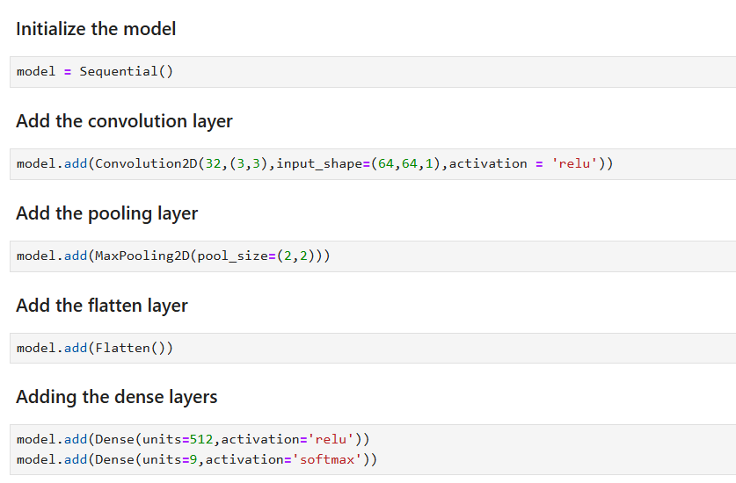

Final Model Selection Justification (2 Marks):
Final Model | Reasoning
CNN | The model processes images, extracts features using convolutional layers, and makes predictions through fully connected layers. It utilizes ReLU activation for hidden layers and Softmax for multi-class classification. The model is trained with categorical cross-entropy loss and the Adam optimizer. It's designed to recognize specific patterns or gestures in images, enabling real-time communication for specially-abled individuals.

